Phone: Office: 0194-24202420405, Ext. 2155

University of Kashmir, Srinagar
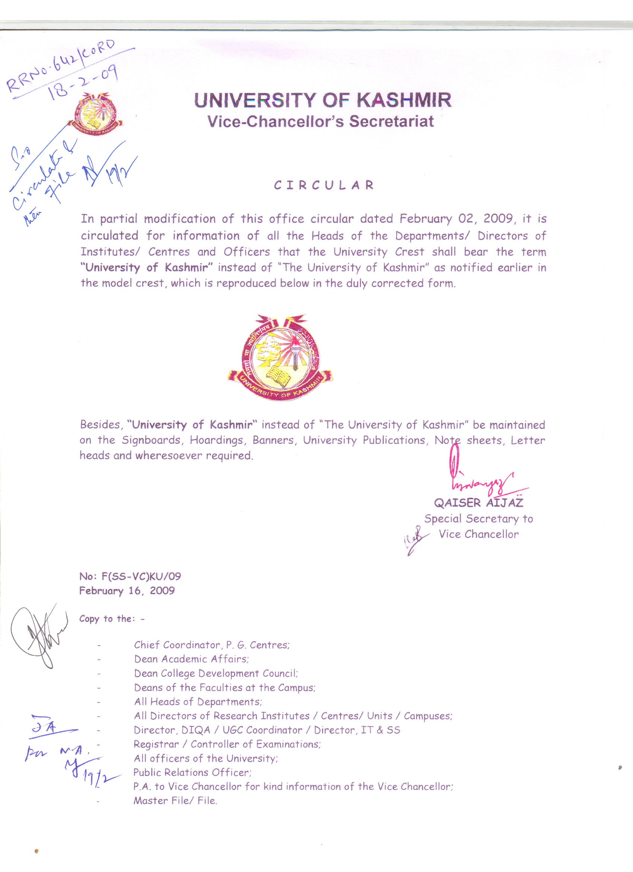
Centre of Research for Development
&
P.G.Department of Environmental Science
Prof. A.N.Kamili
Director/Head

No F(NIT-Equipt)CORD/KU
Dated: 18.06.2013

TENDER NOTICE
Sealed tenders affixed with revenue stamps worth Rs.5/= are invited from registered Dealers/Suppliers for supply of different equipments /instruments to Centre of Research for Development (CORD), University of Kashmir, Hazratbal, Srinagar on the following terms and conditions:

- The items quoted should be of the specifications mentioned against item.
- The rates quoted should be inclusive of all taxes and supply should be for Departmental stores.
- Earnest money of an amount of Rs.5000/= pledged in the name of the undersigned be enclosed with the tender.
- Upto date VAT clearance certificate should be attached with the tender.
- Dealership certificate and certificate to the effect that after sale service will be made available be attached with the tender
- The supply shall have to be made within 20 days from the date of issuing order.
- The tenders should reach by 15th July 2013 upto 4.p.m.
- The list of the equipments/instruments can be had from the official website http:/cord.uok.edu.in or office of the undersigned during office hours.
- A soft copy of lists of items should be provided with the tender documents at the time of submission of tender, failing which the tender will not be entertained.

(Prof. Azra N.Kamili)
D I R E C T O R

Copy to:-
- Assistant Registrar Public Relation Centre, University of Kashmir for publish the above tender in leading local dailies ;
- Incharge, Official Website, CORD, University of Kashmir for placing it on official website

List of Equipment needed in CORD for different laboratories during the year 2013-14

1. Conductivity meter Digital
2. Computer 3 in One
3. Digital balance Max. Cap. 300gms, Readability 0.01g
4. Double water distillation plant (Borosilicate)
5. Heating mantle 200/500 ml. Cap
6. Hot plate
7. Multi-channel pipette (20-200 µl; 8 Channel)
8. Oven
9.pH. meter Digital
10 Storage boxes/Cryobox (-20ºc)
11. UV illuminator for Chromatography
12. Vertical assembly for Gel Electrophoresis
13. Water bath double walled

